**Effectiveness of endoscopic sleeve gastroplasty on loss of total weight: A systematic review and meta-analysis**

**Abstract**

**Introduction:**

Endoscopic Sleeve Gastroplasty (ESG), an emerging minimally invasive procedure, presents a potential alternative to traditional bariatric surgeries for individuals in pursuit of sustained weight reduction. This review aimed to evaluate the effectiveness and safety of ESG in inducing weight loss, recognizing the growing interest in this procedure as a viable option within the spectrum of weight loss interventions.

**Methods:**

A thorough review of the literature was undertaken using PubMed, Scopus, ScienceDirect, and Google Scholar until December 2023. Data on the percentage of total body weight loss (%TBWL), percentage of excess weight loss (%EWL), and adverse event rates were extracted, pooled, and analyzed. Forest plots were generated using random-effects models.

**Results**

Twenty-one studies were incorporated, and data were extracted from a total of 4,985 patients. The aggregated outcomes for BMI reduction at 1, 3, 6, 12, and 18 to 24 months were 3.12 kg/m2, 3.92 kg/m2, 5.58 kg/m2, 6.06 kg/m2, and 6.28 kg/m2, respectively. The cumulative results for %TBWL at 1, 3, 6, and 12 months were 8.42%, 11.83%, 15.43%, and 16.15%, respectively. Additionally, the combined results for %EWL at 1, 3, 6, and 12 months were 28.57%, 43.41%, 53.44%, and 59.49%, respectively. Lastly, the combined incidence rate of abdominal pains was 67% (p < 0.01), and the overall estimate of severe adverse events was only 1%.

**Conclusion**

We found that ESG emerges as a promising and minimally invasive intervention, demonstrating significant reductions in %BMI, %TBWL, and %EWL.

**Introduction**

Obesity, a mounting health concern, has seen a nearly threefold increase in its global prevalence since 1975, as reported by the World Health Organization (WHO) [1]. It is widely recognized that the association between overweight or obesity and an elevated risk of mortality extends to cardiovascular disease, cancer, and Type 2 diabetes (T2D) [2,3]. In the year 2016, excess weight affected over 1.9 billion adults aged 18 and above, with 650 million classified as obese [4]. The repercussions of obesity have been significantly detrimental across various societal dimensions, including healthcare expenses, societal resources, and the potential strain on socio-economic progress [5]. While recommendations often include interventions like diet, exercise, and medications, chosen for their cost-effectiveness and favourable side-effect profiles, these approaches frequently yield less than optimal results.

Diverse approaches are routinely employed to address the multifaceted nature of this complex health concern. Among the array of strategies, prominent methods include diet modification, physical activity, pharmaceutical interventions, and surgical procedures. Diet modification stands out as a foundational approach, involving adjustments in nutritional habits to achieve caloric balance and promote sustainable weight loss. Concurrently, physical activity plays a pivotal role, with regular exercise aiding in calorie expenditure, metabolic regulation, and overall well-being. Pharmaceutical interventions encompass a variety of medications designed to assist individuals in their weight loss journey. These medications often target appetite suppression, fat absorption, or metabolic enhancement [6]. However, they come with their own set of limitations, including potential side effects and varying degrees of efficacy.

For those facing more severe cases of obesity, surgical procedures like bariatric surgery offer a more invasive yet effective solution. These interventions, such as endoscopic bariatric therapies, aim to modify the digestive system, leading to substantial weight loss. Nevertheless, surgical procedures involve inherent risks and necessitate careful consideration. Despite the diversity of approaches, existing weight management methods confront shared limitations and challenges. Adherence to lifestyle modifications can be demanding, and relapses are not uncommon. Moreover, individual responses to pharmaceutical interventions vary, and not everyone may be suitable candidates for surgical procedures. Recognizing these challenges is crucial for refining existing strategies and paving the way for more effective weight management interventions in the future.

Endoscopic bariatric therapies have emerged as an innovative approach to address this gap [7]. To meet the clinical demand effectively, such therapies must not only be safe and efficacious but also appealing to both patients and clinicians. An endoscopic method that eliminates the need for introducing and removing a foreign object could enhance tolerability and durability, potentially increasing adoption rates. One such solution is ESG, a minimally invasive, non-surgical procedure for bariatric treatment introduced in 2013 [8]. ESG works by reducing gastric capacity through an endoluminal suturing system, creating a restrictive sleeve with full-thickness sutures along the stomach's corpus. Despite its demonstrated reproducibility and effectiveness, the broader acceptance of ESG in clinical practice is impeded by the unclear assessment of its safety and efficacy. The primary goal of this systematic review and meta-analysis is to thoroughly investigate the effectiveness of ESG in achieving total body weight loss.

**Methods**

This systematic review and meta-analysis is reported following guidelines outlined in the Preferred Reporting Items for Systematic Review and Meta-Analysis (PRISMA) statement [9].

**Information Sources and Study Selection**

A systematic literature search was conducted for articles published up to 1st December 2023. The index databases used were PubMed, Scopus, ScienceDirect, and Google Scholar. Topic keywords were used to generate search strings. The identified studies were then subjected to a study selection process.

Table 1: Search strings

|  |  |
| --- | --- |
| Databases | Search strings |
| PubMed/Scopus/Google Scholar | ("Gastroplasty" or "Overstitch" or "endosleeve" or "Endoscopic sleeve gastroplasty" or "Endoscopic bariatric therapy" or "Endoscopic suturing" or "Bariatric endoscopy" or "Endobariatrics") AND (“Weight loss” or “Obesity” or “Bariatric”) AND (“endoscopic”) |
| ScienceDirect | ("Endoscopic Sleeve Gastroplasty" OR "ESG" OR "Endoscopic sleeve" OR "Gastroplasty" OR "Endoscopic gastric sleeve") AND ("Weight loss" OR "Total body weight" OR "Body mass index" OR "Obesity") |

**Inclusion and exclusion criteria**

For articles to have been considered eligible for inclusion, the study design had to align with the principles of randomized controlled trials (RCTs), prospective cohort studies, or retrospective cohort studies and written in the English language. Participants who had undergone ESG and had a body mass index (BMI) in the obese range (BMI ≥ 25 kg/m²) were included. Studies that specifically assessed the effectiveness of ESG as a primary intervention for weight loss were incorporated, allowing for variability in ESG techniques and procedures, with the core requirement being endoscopic suturing to create a gastric sleeve. In terms of outcome measures, studies reporting total body weight loss as a primary or secondary outcome, measured as a percentage of the initial body weight were eligible.

Exclusion criteria included study designs such as case reports, case series, letters, comments, editorials, and reviews. Additionally, studies assessing interventions other than endoscopic sleeve gastroplasty for weight loss were not considered, and neither were studies with a primary focus on the treatment of conditions other than obesity. Furthermore, studies without reported total body weight loss or with insufficient data to calculate total body weight loss as a percentage were excluded.

**Review of methodological quality**

The National Institutes of Health (NIH) quality assessment tool for observational cohort and cross-sectional studies was employed to evaluate the quality of the study [10].

**Data Extraction**

A structured table was created to extract relevant information from the studies that met the inclusion criteria. The data encompassed details such as the authors, publication year, country, study setting, duration of data collection, study design, number of patients (including age and gender), and BMI.

**Statistical analysis**

In our meta-analysis, two types of data were analyzed: continuous data, which assessed the efficacy of ESG using metrics like %TBWL and %EWL, and categorical data, specifically a single proportion rate, to evaluate the safety of ESG in terms of adverse events. Proportions with corresponding 95% confidence intervals (CIs) were determined for categorical factors, and mean or median values were obtained for continuous data whenever feasible. Pooled means and proportions were then computed utilizing random-effects models, taking into account the homogeneity or heterogeneity of the studies. Statistical heterogeneity was assessed using I2 statistics and Cochran Q test values, with an I2 value exceeding 50% considered indicative of high statistical heterogeneity (I2 > 50% and P < 0.05). Funnel plots were generated to examine the potential presence of publication bias. All statistical analyses were conducted using R software (version 4.3.2).

**Results**

**Search results**

The preliminary search yielded a total of 6,754 articles retrieved from various databases, including 1,020 from Scopus, 4,884 from ScienceDirect, 754 from PubMed, and 100 from Google Scholar. After eliminating 297 duplicate entries, a comprehensive title and abstract screening process excluded 6,330 articles based on predefined eligibility criteria. Subsequently, the remaining 116 articles underwent a thorough full-text review. Out of these, 95 articles were excluded as they did not fully meet the inclusion criteria. Ultimately, 21 studies met the criteria and were included in the systematic review and meta-analysis. The PRISMA flowchart in Figure 1 outlines the reasons for exclusion.

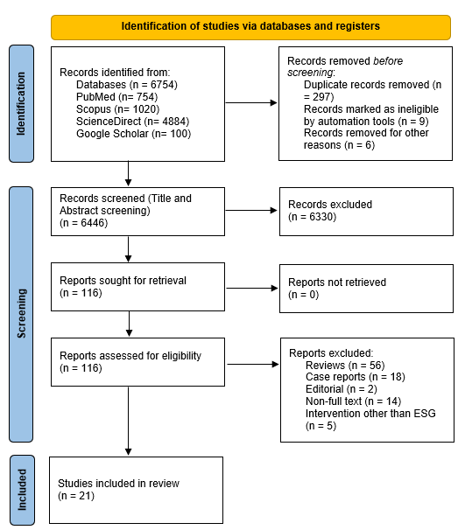

Figure 1: PRISMA flowchart showing the study selection process

**Results of quality appraisal**

The outcomes of the quality evaluation for all the included studies were deemed satisfactory. Two studies received a rating of ‘fair’ while the remaining 19 studies achieved a rating of 'good' in terms of overall quality. Please refer to Table 2 in the appendix for a detailed presentation of these assessments.

**Results of data extraction**

Table 3: Study Descriptor table

|  |  |  |  |  |  |  |  |  |
| --- | --- | --- | --- | --- | --- | --- | --- | --- |
| Author(s) | Year of publication | Country | Study setting | Data period | Study Design | No. of patients (M/F) | Mean Age ± (SD), years | BMI (mean ± SD), kg/m^2 |
| Abu Dayyeh et al. | 2022 | United States | Multicenter | 12/2017-06/2019 | RCT | 77 (9/68) | 47.3 ± 9.3 | 35.5 |
| Abu Dayyeh et al. | 2017 | United States | Single center | 09/2012–03/2015 | Prospective cohort | 25 (4/21) | 47.6 ± 10 | 35.5 ± 2.6 |
| Alqahtani et al. | 2018 | Saudi Arabia | Single center | 12/2016- NR | Prospective cohort | 1000 (897/103) | 34.4 ± 9.5 | 33.3 ± 4.5 |
| Alqahtani et al. | 2019 | Saudi Arabia | Single center | 24 months | Retrospective cohort | 109 (10/99) | 17.6 ± 2.2 | 33 ± 4.7 |
| Asokkumar et al. | 2021 | Singapore | Multicenter | 11/2020-09/2021 | Retrospective cohort | 35 (15/20) | 43.6 ± 11.3 | 34 ± 4.9 |
| Barrichello et al. | 2019 | Multicenter | Multicenter | 07/2017 – 08/2018 | Prospective cohort | 193 (45/148) | 42.3 ± 9.6 | 34.11 ± 2.97 |
| Bhandari et al. | 2020 | India | Single center | 03/2017-10/2018 | Retrospective cohort | 53 (10/43) | 40.54 ± 13.79 | 34.78 ± 5.2 |
| Brunaldi et al. | 2023 | Multicenter | Multicenter | 36 months | Retrospective cohort | 189(NR) | 42.6±14.1 | 27.79 ± 1.17 |
| Espinet-Coll et al. | 2020 | Spain | Multicenter | 03/2014-02/2019 | Retrospective cohort | 88 (27/61) | 46.1 ± 12.3 | 39.4 ± 4.69 |
| Fayad et al. | 2018 | United States | Single center | 05/2015–12/2016 | Retrospective cohort | 54 (31/23) | 48 ± 12 | 43.0 ± 8.9 |
| Gala et al. | 2023 | United States | Multicenter | 01/2013-08/2022 | Retrospective cohort | 1506 (233/1273) | 45.68 ± 10.25 | 38.43 ± 6.22 |
| Graus-Morales et al. | 2018 | Spain | Single center | 01/2015–02/2016 | Retrospective cohort | 148 (27/121) | 41.5 ± 10 | 35.1 ± 5.5 |
| James et al. | 2020 | United States | Single center | 05/2018-07/2019 | Retrospective cohort | 100 (14/86) | 45 ± 9 | 38.41 ± 5.44 |
| Lopez-Nava et al. | 2016 | Spain | Single center | 2013.05–2015.07 | Prospective cohort | 55 (13/42) | 43.5 ± 8.1 | 37.7 ± 4.5 |
| Lopez-Nava et al. | 2017 | Spain | Single center | 2013.05–2016.03 | Prospective cohort | 154 (46/108) | NR | 38.3 ± 5.5 |
| Lopez-Nava et al. | 2017 | Spain | Multicenter | 2013.01–2015.12 | Retrospective cohort | 248 (NR) | 44.5 ± 10 | 37.8 ± 5.6 |
| Maseli et al. | 2023 | United States | Multicenter | 05/2018-03/2022 | Retrospective cohort | 404 (87/317) | 42.9 | 44.8 ± 4.7 |
| Sartoretto et al. | 2018 | United States | Multicenter | 2016.02–2017.05 | Retrospective cohort | 112 (31/81) | 45.1 ± 11.7 | 37.9 ± 6.7 |
| Saumoy et al. | 2018 | United States | Single center | 2013.08–2016.12 | Prospective cohort | 128 (42/86) | 43.62 ± 11.37 | 38.92 ± 6.95 |
| Sharaiha et al. | 2021 | United States | Single center | 08/2013-09/2019 | Prospective cohort | 216 (70/146) | 46 ± 13 | 39 ± 6 |
| Sharaiha et al. | 2017 | United States | Single center | 2013.08–2016.03 | Prospective cohort | 91 (29/62) | 43.66 ± 11.26 | 38.6 ± 7.0 |

**Characteristics of included studies**

This paper included 21 studies, each shedding light on the efficacy of ESG. The research settings encompassed both single-centre and multicenter environments, showcasing the diverse clinical contexts in which ESG has been explored. Study designs included randomized controlled trials, prospective cohorts, and retrospective cohorts, delivering a comprehensive overview of the available evidence. These studies exhibited substantial variability, with cohort sizes ranging from as few as 25 participants to over 1500 individuals in larger multicenter investigations. The mean age of participants in the studies varied widely, spanning from approximately 17.6 years to 48 years, indicating the inclusion of diverse age groups in the analyses. Similarly, the mean BMI across the studies showed considerable diversity, with values ranging from 27.79 kg/m² to 44.8 kg/m², reflecting the broad spectrum of individuals undergoing ESG.

**Results of included studies: summary**

In a prospective cohort study conducted by Abu Dayyeh et al. [11], the durability of ESG was examined, along with its impact on body weight and gastrointestinal function. The findings suggested that ESG slows down the emptying of the stomach, triggers a sense of early fullness, and leads to a substantial decrease in body weight. The study also proposed that for specific individuals with obesity, ESG might serve as a viable alternative to traditional bariatric surgery. In a randomized controlled trial conducted by Abu Dayyeh et al. [12], the effectiveness and safety of ESG combined with lifestyle modifications were examined in comparison to lifestyle modifications alone. The researchers found that ESG proved to be a secure intervention, leading to substantial and sustained weight loss even after 104 weeks, accompanied by notable enhancements in metabolic comorbidities. The study suggests that ESG could be considered a collaborative weight loss intervention for individuals with class 1 or class 2 obesity. In a study conducted by Alqahtani et al. [13], the focus was on weight loss, morbidity, revisions, and comorbidity resolution within the initial 18 months following primary ESG in a cohort of 1000 consecutive patients. The findings indicated that ESG was well received, deemed safe, and showcased effectiveness. Notably, substantial weight loss was observed in the initial 18 months without any occurrences of mortality or significant morbidity. However, it was noted that some patients required revision or reversal procedures within the first year. Alqahtani et al. [14] additionally documented their experience with ESG in the initial 109 pediatric patients with obesity who underwent the procedure under their supervision. The study revealed that ESG was both safe and effective for children and adolescents with obesity. Notably, substantial weight loss was observed within the initial 2 years, without any instances of mortality or significant morbidity, and this weight loss appeared to be sustained over time. A retrospective study by Asokkumar et al. [15] evaluated the safety and effectiveness of ESG within a multi-ethnic Asian population. The researchers concluded that ESG proves to be a safe and efficient choice for facilitating weight loss in this diverse demographic. The weight loss induced by ESG could potentially lead to improvements in obesity-related comorbidities.

Barrichello et al. [16] conducted a study evaluating outcomes across all BMI categories and examining alterations in metabolic rate, lean body mass, and adipose tissue composition following a consistent "U" stitch in 193 patients. The findings indicated a noteworthy decrease in adipose tissue from the baseline. As a result, the authors concluded that ESG seemed to be a viable, secure, and efficient approach to managing individuals with overweight and obesity, aligning with the thresholds set by ASGE/ASMBS. Bhandari et al. [17] explored the effectiveness and safety of ESG in a cohort of 53 Indian patients. The findings revealed that ESG proved to be both effective and safe in facilitating weight loss within the Indian population. Notably, the study suggested that better outcomes were associated with younger age and female gender. Another study by Brunaldi et al. [18] concluded that ESG is a safe and effective treatment for overweight patients, exhibiting high rates of BMI normalization. The procedure may contribute to arresting or delaying the progression of obesity. A study by Espinet-Coll et al. [19] aimed to assess whether the suture pattern used in ESG influences its efficacy. The researchers concluded that, at the 12-month follow-up, ESG is an effective procedure for achieving weight loss and resolving comorbidities. The analysis of three different suture patterns (transverse bilinear [TBp], longitudinal [Lp], and transverse monolinear [TMp]) indicated that all were safe and effective, showing no significant differences in %TBWL. However, there was a slight increase in %EWL in the longitudinal pattern (Lp), regardless of the number of sutures or stitches applied.

In a study by Fayad et al. [20], a comparison was made between 6-month weight loss outcomes and adverse events of ESG and laparoscopic sleeve gastrectomy (LSG) in a case-matched cohort. The findings indicated that ESG patients experienced significantly lower rates of adverse events compared to LSG patients (5.2% vs. 16.9%, P < .05). Furthermore, the incidence of new-onset gastroesophageal reflux disease (GERD) was significantly lower in the ESG group compared to the LSG group (1.9% vs. 14.5%, P < .05). Despite achieving less weight loss at 6 months than LSG, ESG was associated with fewer adverse events and new-onset GERD compared to LSG. Gala et al. [21] shared outcomes from the largest cohort of United States patients undergoing ESG and assessed these outcomes based on obesity class. The findings revealed that within 6 months post-ESG, the mean BMI for each class dropped to the next lower class, maintaining this level over the subsequent 2 years. The Class III group demonstrated significantly greater %TWBL at all time points compared to other classes. At the 12-month mark, 83.2% and 60.9% of patients across all classes achieved ≥10% and ≥15% total body weight loss (%TBWL), respectively. Importantly, there were no notable differences in adverse events observed between the different obesity classes, affirming the safety of ESG even in higher obesity classes, with acceptable mid-term efficacy. Graus-Morales et al. [22] concentrated on a modified technique that proposed an alternative suturing pattern to achieve a more even distribution of suture tension. The reported outcomes indicated a total weight loss percentage (%TWL) of 17.53±7.57 at 12 months and 18.5±9% at 18 months, signifying the lasting effectiveness of the procedure. These results underscore that Endoscopic Gastroplasty presents a viable option for individuals dealing with obesity.

In a retrospective cohort study conducted by James et al. [23], an assessment was made on TBWL, procedure duration, improvements in metabolic comorbidities, and the rate and severity of adverse events (AE) in 100 patients who underwent ESG at a private, community-based gastroenterology practice. The findings revealed a mean 12-month TBWL of 29.80 ± 11.46 kg (23.1 ± 7.5%), with an excess weight loss of 66.1 ± 21.5%. Additionally, over this period, the mean change in BMI was 9.43 ± 0.22. Lopez-Nava et al. [24] presented safety and efficacy results after 6 months in patients undergoing ESG. The authors noted the absence of major complications, with patients being discharged within 24 hours post-procedure. Endoscopic and radiographic follow-up at the 6-month mark demonstrated a well-preserved tubular form of the stomach. By this point, patients had lost 18.9 kg and 55.3% of excess weight. Consequently, the authors concluded that ESG, when combined with dietary and psycho-behavioural changes, stands as a safe and effective technique in the supportive management of obese patients. In another study by Lopez-Nava et al. [25], findings at 24 months post-procedure indicated a significant reduction in mean BMI from 38.3 to 30.8 kg/m². TBWL, %TBWL, and %EWL were reported as 21.3 kg, 19.5%, and 60.4%, respectively. Remarkably, 85.7% of patients achieved the goal of >25% %EWL. No major adverse events were recorded either during the procedure or throughout the 24-month follow-up period. Consequently, the authors concluded that ESG, when coupled with regular monitoring by a multidisciplinary team, can be deemed an effective, safe, and well-tolerated procedure for treating obesity, at least within a two-year follow-up period. Lopez-Nava et al. [26] assessed the long-term outcomes, reproducibility, and predictors of weight response in a sizable multicenter cohort comprising 248 patients. The reported results at 6 and 24 months showed a %TBWL of 15.2 [95%CI 14.2-16.3] and 18.6 [15.7-21.5], respectively. At the 24-month mark, the percentage of patients achieving ≥10% TBWL was 84.2% with per-protocol (PP) analysis and 53% with intention-to-treat (ITT) analysis. The odds of achieving ≥10% TBWL at 24 months for patients who achieved <10% TBWL at 6 months were 0.18 [0.034-0.84]. Only five (2%) serious adverse events were reported. The authors concluded that ESG effectively induces weight loss over 24 months in moderately obese patients. Early prediction of inadequate weight loss allows for the identification of patients who may benefit from adjunctive therapies to enhance the weight loss process.

Maseli et al. [27] conducted an assessment of the safety, clinical efficacy, and durability of ESG in adults with class III obesity, involving 404 patients. The reported results indicated a TBWL of 20.9 ± 6.2% at 12 months, 20.5 ± 6.9% at 24 months, and 20.3 ± 9.5% at 36 months. EWL was 49.6 ± 15.1% at 12 months, 49.4 ± 16.7% at 24 months, and 47.1 ± 23.5% at 36 months. No significant difference in TBWL was observed at 12, 24, and 36 months post-ESG. The authors concluded that when combined with ongoing nutritional support, ESG leads to effective and lasting weight loss in adults with class III obesity, accompanied by improvements in comorbidities and maintaining an acceptable safety profile. A cohort study by Sartoretto et al. [28] investigated the reproducibility, efficacy, and safety of ESG across three centres in two countries (Australia and the US). They identified key determinants for procedural success in a cohort of 112 ESG patients. The reported results showed that at 1, 3, and 6 months, the weight change was 9.0 ± 4.6 kg TBWL 8.4 ± 4.1%), 12.9 ± 6.4 kg (TBWL 11.9 ± 4.5%), and 16.4 ± 10.7 kg (TBWL 14.9 ± 6.1%), respectively. The proportion of patients achieving more than 10% TBWL and 25% EWL was 62.2% and 78.0% at 3 months post-ESG and 81.0% and 86.5% at 6 months post-ESG. Importantly, weight loss was similar across all three centres. Consequently, the study concluded that ESG is an effective, reproducible, and safe weight loss therapy suitable for widespread clinical adoption. In a single-centre study conducted by Saumoy et al. [29], an analysis was performed on 128 patients who underwent ESG. At the 12-month mark, the reported mean per cent TBWL was 15.8% (9.47%), with 71.7% of patients achieving successful weight loss. The authors concluded that the mastery of ESG by a single operator is indicated after acquiring sufficient endoscopic experience, and this expertise may contribute to guiding widespread clinical adaptability.

In a prospective cohort study by Sharaiha et al. [30], the long-term safety and efficacy of ESG for obesity treatment were assessed in 216 patients. The reported results indicated that at the 5-year mark, the mean TBWL was 15.9% (95% CI 11.7-20.5, p < 0.001), with 90% and 61% of patients maintaining 5% and 10% TBWL, respectively. The overall rate of moderate AEs was 1.3%, with no severe or fatal AEs recorded. The authors concluded that ESG is a safe and effective option for obesity treatment, providing durable long-term results for at least up to 5 years post-procedure. They recommend considering this procedure as a reliable option for obesity treatment. In another study by Sharaiha et al. [31], the effects of ESG on total body weight loss and obesity-related comorbidities were assessed in 91 consecutive patients. The reported results indicated that, at 6 months (80% follow-up rate), patients had lost 14.4% of their total body weight, followed by 17.6% at 12 months (76% follow-up rate), and 20.9% at 24 months (66% follow-up rate) after the ESG procedure. At the 12-month mark, patients experienced statistically significant reductions in levels of haemoglobin A1c (P=0.01), systolic blood pressure (P=0.02), waist circumference (P<0.001), alanine aminotransferase (P<0.001), and serum triglycerides (P=0.02). However, there was no significant change in low-density lipoprotein after vs before ESG (P=0.79). Notably, one serious adverse event (perigastric leak) occurred, constituting 1.1%, and it was managed non-operatively.

**BMI Reduction**

A reduction in BMI was reported at various time points, namely 1 month, 3 months, 6 months, 12 months, and 18–24 months (refer to Figure 2). Utilizing the random-effects model, the combined BMI loss was 3.12 kg/m2 (95% CI, 2.58–3.78) after 1 month (Cochran Q test P < 0.01, I2 = 98%), 3.92 kg/m2 (95% CI, 3.36–4.57) after 3 months (Cochran Q test P < 0.01, I2 = 98%), 5.58 kg/m2 (95% CI, 4.91–6.34) after 6 months (Cochran Q test P < 0.01, I2= 95%), 6.06 kg/m2 (95% CI, 5.22–7.04) after 12 months (Cochran Q test P < 0.01, I2 = 83%), and 6.28 kg/m2 (95%CI 5.02–7.87) after 18–24 months.

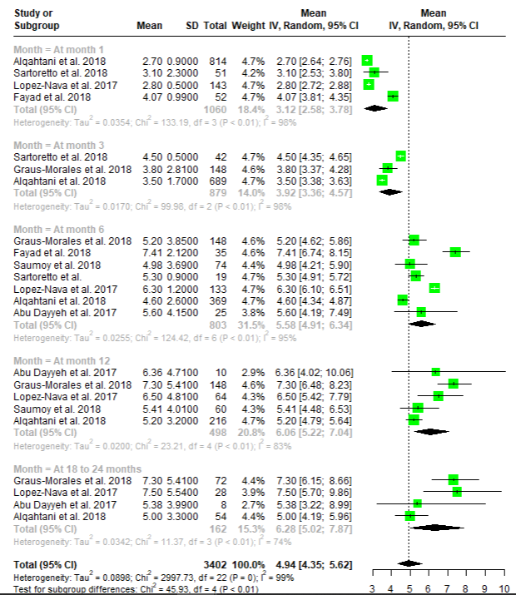

Figure 2: Forest plots depicting the assessed studies examining patient BMI reduction

**Proportional TBWL**

TBWL was reported at various time intervals, specifically at 1 month, at 3 months, at 6 months, at 12 months, and 18–24 months (refer to Figure 3). Employing the random-effects model, the collective mean TBWL was 8.42% (95% CI, 7.54%–9.40%) at 1 month (Cochran's Q test P <0 .01, I2 = 92%), 11.83% (95% CI, 10.37%–13.51%) at 3 months (Cochran's Q test P< 0.01, I2 = 96%), 15.43% (95% CI, 13.97%–17.05%) at 6 months (Cochran's Q test P < 0.01, I2 = 84%), and 16.15% (95% CI, 14.27%–18.27%) at 12 months (Cochran's Q test P < 0.04, I2 = 68%).

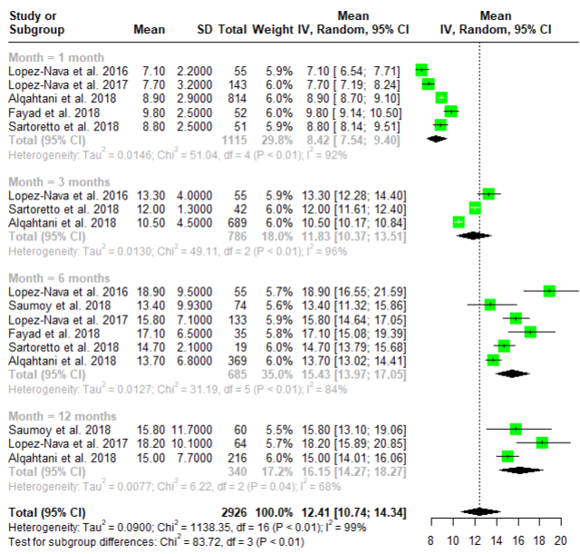

Figure 3: Forest plots of the included studies evaluating TBWL.

**Proportional EWL**

EWL was reported at different intervals, specifically at 1 month, 3 months, 6 months, and 12 months (refer to Figure 4). Utilizing the random-effects model, the combined EWL was 28.57% (95% CI, 22.44%–36.38%) at 1 month (Cochran Q test P < 0.01, I2 = 98%), 43.43% (95% CI, 37.70%–49.99%) at 3 months (Cochran Q test P < 0.01, I2 =95%), 53.44% (95% CI, 47.93%–59.59%) at 6 months (Cochran Q test P < 0.01, I2 = 86%), and 59.49% (95% CI, 49.9%–72.10%) at 12 months (Cochran Q test P = 0.01, I2 = 74%).

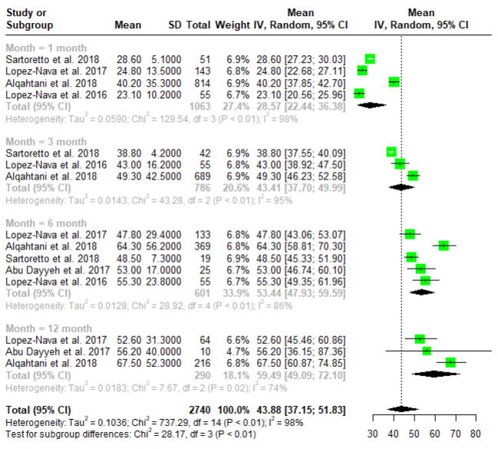

Figure 4: Forest plots of studies assessing patient EWL

**Abdominal Pain**

Abdominal pain and nausea emerged as the prevalent mild adverse events, with their combined estimate illustrated in Figure Y. The aggregated rate stood at 67% (95% CI 54–80%, I2 = 96%, p < 0.01, n = 1334), indicating notable heterogeneity.

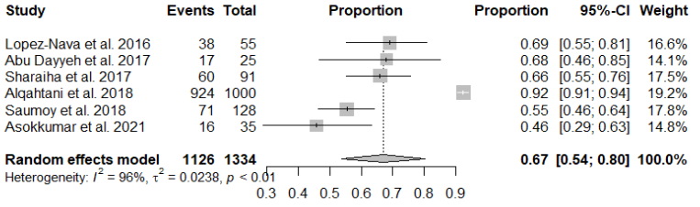

Figure 5:Forest plot of the rate of abdominal pain

**Adverse Events**

All trials encompassed in the meta-analysis documented procedural severe adverse events, as illustrated in Figure X. The combined assessment revealed a post-endoscopic submucosal dissection (ESG) severe adverse event rate of 1% (95% CI, 0.1%–2.0%), accompanied by a moderate level of heterogeneity (Cochran Q test P = 0.18, I2 = 27).

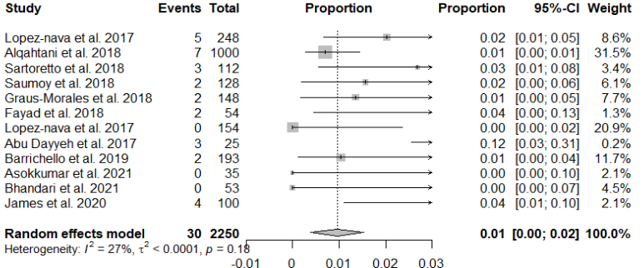

Figure 6:Forest plot of the rate of severe adverse events

**Discussion**

The meta-analysis of studies assessing the effectiveness of Endoscopic Sleeve Gastroplasty (ESG) on weight loss reveals compelling evidence from diverse cohorts. Several investigations collectively contribute to a comprehensive understanding of the impact of ESG on total body weight. Notably, the results suggest a consistent trend towards substantial and sustained weight loss across various study designs and patient populations.

Investigation by Abu Dayyeh et al. (2017) emphasized the durability of ESG, demonstrating its ability to slow stomach emptying, induce early satiety, and lead to a significant decrease in body weight. Furthermore, the study proposed ESG as a viable alternative to traditional bariatric surgery for specific individuals with obesity. The findings of a randomized controlled trial (Abu Dayyeh et al., 2022) reinforced the efficacy of ESG, revealing secure intervention and sustained weight loss over 104 weeks, accompanied by notable improvements in metabolic comorbidities. This study suggested the potential consideration of ESG as a collaborative weight loss intervention for individuals with class 1 or class 2 obesity. Alqahtani et al. (2019) focused on the initial 18 months following primary ESG in a large cohort and reported well-received, safe, and effective outcomes. Despite substantial weight loss, some patients required revision or reversal procedures within the first year. Notably, their experience with ESG in pediatric patients affirmed its safety and efficacy for children and adolescents with obesity. Asokkumar et al. (2021) extended the evidence to a multi-ethnic Asian population, concluding that ESG is a safe and efficient choice for facilitating weight loss, potentially improving obesity-related comorbidities. Barrichello et al. (2019) explored outcomes across all BMI categories, reporting a significant decrease in adipose tissue and endorsing ESG as a viable, secure, and efficient approach for managing individuals with overweight and obesity. Bhandari et al. (2019) further supported the effectiveness and safety of ESG in an Indian population, suggesting better outcomes associated with younger age and female gender. Brunaldi et al. (2023) reinforced the notion that ESG is a safe and effective treatment for overweight patients, exhibiting high rates of BMI normalization.

The influence of suture patterns on ESG outcomes was explored by Espinet-Coll et al. (2020), indicating the overall effectiveness of ESG for weight loss and comorbidity resolution across different suture patterns. Additionally, Fayad et al. (2019) conducted a comparative analysis between ESG and laparoscopic sleeve gastrectomy (LSG), revealing that ESG, despite achieving less weight loss at 6 months, was associated with fewer adverse events and new-onset gastroesophageal reflux disease. Gala et al. (2023) presented outcomes from the largest cohort of United States patients, affirming the effectiveness and safety of ESG across different obesity classes. Graus-Morales et al. (2018) introduced a modified technique, reporting lasting effectiveness with total weight loss percentages of 17.53±7.57 at 12 months and 18.5±9% at 18 months. James et al. (2019) reported significant total body weight loss and improvements in metabolic comorbidities at 12 months. Lopez-Nava et al. (2016, 2017) highlighted the safety and efficacy of ESG, with substantial weight loss and improvements in comorbidities. Furthermore, they assessed long-term outcomes, indicating effective weight loss over 24 months in moderately obese patients. Maseli et al. (2023) provided evidence supporting ESG's effectiveness and lasting weight loss in adults with class III obesity. Sartoretto et al. (2018) concluded that ESG is an effective, reproducible, and safe weight loss therapy suitable for widespread clinical adoption. Saumoy et al. (2018) emphasized the mastery of ESG by a single operator and its potential contribution to widespread clinical adaptability. Sharaiha et al. (2017, 2020) assessed the long-term safety and efficacy, indicating durable results up to 5 years post-procedure, with a low rate of adverse events.

The meta-analysis of studies investigating the effectiveness of ESG for weight loss revealed findings that aligned with and contributed to the existing body of literature. Across diverse patient populations and study designs, consistent trends emerged, highlighting ESG's effectiveness in inducing substantial and sustained weight loss. Studies by Abu Dayyeh et al. (2017, 2022), and Alqahtani et al. (2019) consistently reported positive outcomes, emphasizing the procedure's safety profile and improvements in metabolic comorbidities. Notably, the meta-analysis was in concordance with the broader literature on ESG's favourable weight loss efficacy and safety. However, notable differences enriched our understanding, as evidenced by Fayad et al.'s (2019) comparison with laparoscopic sleeve gastrectomy (LSG) and the exploration of procedural variations in suture patterns by Espinet-Coll et al. (2020). The focus on pediatric populations (Alqahtani et al., 2019) and long-term outcomes (Lopez-Nava et al., 2016, 2017; Sharaiha et al., 2020) added valuable dimensions to the literature. Gala et al. (2023) extended insights by examining outcomes across different obesity classes, affirming ESG's safety and efficacy even in higher obesity classes. The findings from the included studies, align with and find support in other relevant literature that was not initially mentioned. A systematic review by Li et al. [32] reinforced the consistent trends observed in your results, emphasizing ESG's efficacy in inducing weight loss and promoting overall health through improvements in comorbidities. Similarly, Mehta and Sharaiha [33] contributed to this consistency by reporting significant total body weight loss (TBWL) and metabolic improvements over 12 months. Going beyond the scope of provided studies, Nunes et al. [34] introduced a nuanced perspective by exploring the impact of ESG on patients with obesity-related non-alcoholic fatty liver disease (NAFLD), showcasing positive outcomes in liver function alongside weight loss.

Additionally, Fayad et al. [35] delved into the psychological aspects of ESG outcomes, indicating positive effects on mental well-being. While not directly addressing weight loss, this study complements your results by suggesting potential psychological benefits associated with ESG. Furthermore, studies by Payne et al. [36], Gala et al. [37] and Matteo et al. [38] introduced demographic and condition-specific nuances, respectively, showcasing the efficacy of ESG across elderly populations and patients with diabetes. In a similar vein, Novikov et al. [39] specifically examined ESG outcomes in patients with diabetes, showcasing significant improvements in glycemic control alongside weight loss.

The subgroup analysis of BMI reduction post-ESG revealed a progressive and sustained trend over various time points. At 1 month, a rapid reduction of 3.12 kg/m2 was observed, with high heterogeneity (I2 = 98%). Subsequent intervals showed increased BMI loss: 3 months (3.92 kg/m2), 6 months (5.58 kg/m2), 12 months (6.06 kg/m2), and 18–24 months (6.28 kg/m2). While heterogeneity persisted, particularly in early time points, these results underscored the efficacy of ESG in achieving and maintaining significant BMI reduction over both short and extended periods. The meta-analysis conducted on %TBWL subgroup analysis after ESG revealed a consistent and progressive trend over various time points. At 1 month, %TBWL was 8.42%, indicating an initial substantial weight reduction. The trend continued at 3 months (11.83%, I2 = 96%) and 6 months (15.43%, I2 = 84%), showcasing sustained effectiveness. By 12 months, %TBWL reached 16.15%, with decreased heterogeneity (I2 = 68%). The analysis of %EWL post-ESG demonstrated a consistent and substantial trend over different time points. At 1 month, %EWL was 28.57%, highlighting an early and significant excess weight loss. This trend continued at 3 months (43.43%) and 6 months (53.44%), indicating sustained effectiveness. By 12 months, %EWL reached 59.49%, with decreased heterogeneity (I2 = 74%). These findings showcased ESG's efficacy in achieving substantial excess weight loss, providing valuable insights for clinical considerations and further research. The analysis of mild adverse events post-endoscopic Sleeve Gastroplasty (ESG) revealed that abdominal pain and nausea were the predominant issues, with an aggregated rate of 67%. Lastly, analysis of procedural severe adverse events post-ESG across all trials revealed a combined rate of 1% (95% CI, 0.1%–2.0%), indicating a relatively low occurrence of severe adverse events.

The study illuminated the critical clinical implications of ESG in the realm of weight loss interventions. ESG emerged as a compelling option, showcasing notable efficacy in inducing weight loss with a sustained reduction in BMI, %TBWL, and %EWL across various time intervals. Positioned as a viable alternative, particularly for individuals with class 1 or class 2 obesity, ESG demonstrated substantial and lasting weight loss coupled with improvements in metabolic comorbidities. The procedure's favourable safety profile, characterized by a low rate of severe adverse events (1%), reinforced its acceptability. Mild adverse events, such as abdominal pain and nausea, were common but manageable, contributing to the overall feasibility and safety of ESG as a weight loss intervention.

**Conclusion**

This systematic review and meta-analysis offer a comprehensive assessment of the effectiveness and safety of ESG in promoting weight loss. The synthesized evidence highlighted ESG's notable impact on reducing body mass index, total body weight loss (%TBWL), and excess weight loss (%EWL) across various time intervals. Importantly, the procedure demonstrated a favourable safety profile, with low rates of severe adverse events and manageable mild events. Our findings suggest that ESG stands out as a promising intervention for individuals seeking sustained weight loss, particularly those with class 1 or class 2 obesity. The clinical implications underscore ESG's potential as a valuable addition to the array of available weight loss strategies.

**Appendix**

Table 2: Quality results

|  |  |  |  |  |  |  |  |  |  |  |  |  |
| --- | --- | --- | --- | --- | --- | --- | --- | --- | --- | --- | --- | --- |
| Author | A clear definition of the research question | A clear definition of the study population | A 50% participation of eligible persons | Recruitment from similar populations | Sample size justification, power description, and effective estimates | Measurement of exposure before the outcome assessment | Sufficient timeframe between exposure and outcomes | A clear definition, validity, reliability, and consistent implementation of exposure measures across participants | Blinding of outcome assessors | Less than 20% loss to follow-up | Measurement and adjustment of potential confounding factors | Overall quality rating |
| Abu Dayyeh et al. 2022 | Yes | Yes | Yes | Yes | Yes | Yes | Yes | Yes | No information | Yes | Not Applicable | Good |
| Abu Dayyeh et al. 2017 | Yes | Yes | Yes | Yes | Yes | Yes | Yes | Yes | No information | Yes | Not Applicable | Good |
| Alqahtani et al. 2018 | Yes | Yes | Yes | Yes | Yes | Yes | Yes | Yes | No information | Yes | Not Applicable | Good |
| Alqahtani et al. 2019 | Yes | Yes | Yes | Yes | Yes | Yes | Yes | Yes | No information | Yes | Not Applicable | Good |
| Asokkumar et al. 2021 | Yes | Yes | Yes | Yes | Yes | Yes | Yes | Yes | No information | Yes | Not Applicable | Good |
| Barrichello et al. 2019 | Yes | Yes | Yes | Yes | Yes | Yes | Yes | Yes | No information | Yes | Not Applicable | Good |
| Bhandari et al. 2020 | Yes | Yes | Yes | Yes | Yes | Yes | Yes | Yes | No information | Yes | Not Applicable | Good |
| Brunaldi et al. 2023 | Yes | Yes | Yes | Yes | Yes | Yes | Yes | Yes | No information | Yes | Not Applicable | Good |
| Espinet-Coll et al. 2020 | Yes | Yes | Yes | No | Yes | No | Yes | Yes | No information | Yes | Not Applicable | Good |
| Fayad et al. 2018 | Yes | Yes | Yes | Yes | Yes | Yes | Yes | Yes | No information | Yes | Not Applicable | Good |
| Gala et al. 2023 | Yes | Yes | Yes | Yes | Yes | Yes | Yes | Yes | No information | Yes | Not Applicable | Good |
| Graus-Morales et al. 2018 | Yes | Yes | Yes | Yes | Yes | Yes | No | Yes | No information | Yes | Not Applicable | Fair |
| James et al. 2020 | Yes | No | No | Yes | Yes | Yes | Yes | Yes | No information | Yes | Not Applicable | Fair |
| Lopez-Nava et al. 2016 | Yes | Yes | Yes | Yes | Yes | Yes | Yes | Yes | No information | Yes | Not Applicable | Good |
| Lopez-Nava et al. 2017 | Yes | Yes | Yes | Yes | Yes | Yes | Yes | Yes | No information | Yes | Not Applicable | Good |
| Lopez-Nava et al. 2017 | Yes | Yes | Yes | Yes | Yes | Yes | Yes | Yes | No information | Yes | Not Applicable | Good |
| Maseli et al. 2023 | Yes | No | Yes | Yes | Yes | Yes | Yes | Yes | No information | Yes | Not Applicable | Fair |
| Sartoretto et al. 2018 | Yes | Yes | Yes | Yes | Yes | No | Yes | Yes | No information | Yes | Not Applicable | Good |
| Saumoy et al. 2018 | Yes | Yes | Yes | Yes | Yes | Yes | Yes | Yes | No information | Yes | Not Applicable | Good |
| Sharaiha et al. 2021 | Yes | Yes | Yes | Yes | Yes | Yes | Yes | Yes | No information | Yes | Not applicable | Good |
| Sharaiha et al. 2017 | Yes | Yes | Yes | Yes | Yes | Yes | Yes | Yes | No information | Yes | Not Applicable | Good |